**Mr SGs Intermolecular Forces Notes**

**Van der Waals Forces**

-Van der Waals forces (intermolecular forces) are the weak forces of attraction between molecules in all molecular substances

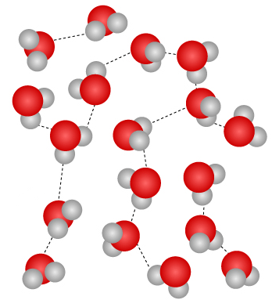

-While a molecule’s chemical properties are affected by its intramolecular forces (e.g. its bonding), its physical properties are determined by its intermolecular forces

-Whenever a substance melts, boils, is physically manipulated or dissolves, intermolecular forces are either being broken, formed or both

-The stronger the intermolecular forces in a substance, the higher the melting and boiling points and the greater the viscosity/hardness.

**What are Intermolecular Forces?**

-Intermolecular forces are the forces of attraction between positive and negative charges (dipoles) on adjacent molecules

-Dipoles are defined as positively and negatively charged regions of a molecule that are separated by a distance

-The strength of intermolecular forces is determined by the strength of these dipoles and the distance between them

-The strength of the dipoles depends on the polarity of the molecule, which is determined by the polarity of its bonds and the 3D shape of a molecule

-In order to determine the type and strength of intermolecular forces a molecule will experience, it is necessary to determine the shape of the molecule

**VSEPR & Molecular Shapes**

-The Valence Shell Electron Pair Repulsion (VSEPR) theory is used to predict molecule shapes

-It states that the electron pairs (both bonding and non-bonding) in the valence shell of an atom repel each other and are therefore arranged as far apart as possible due to the repulsion between them

In order to determine the shape of a simple molecule:

1. Draw the Lewis structure

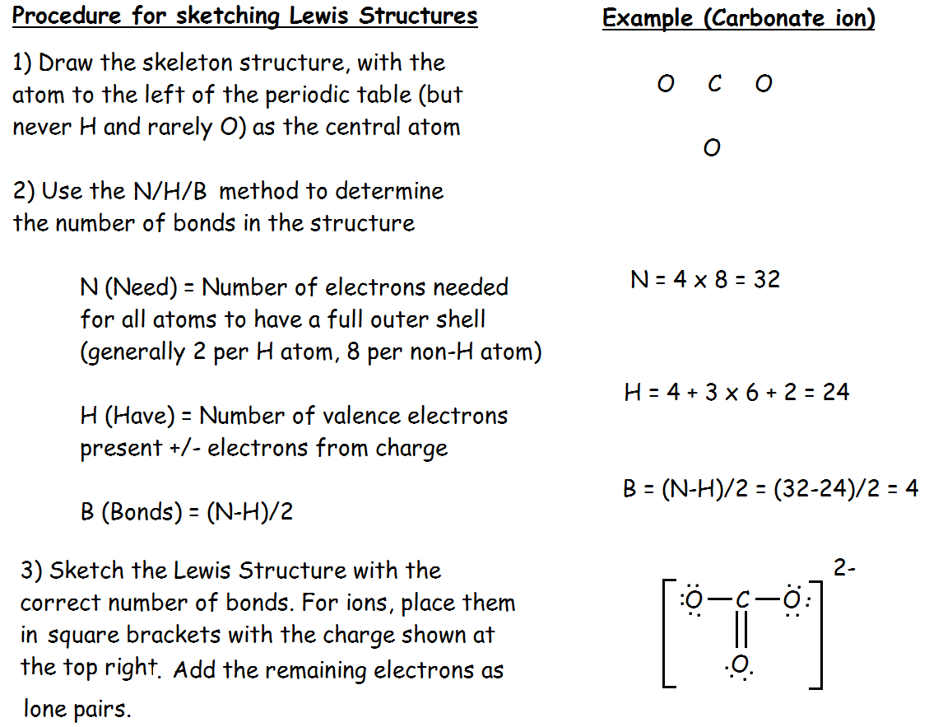

1. Determine the 3D shape (linear/triangular planar, tetrahedral/pyramidal/ bent) by maximising the distance between the electron pairs (both bonding and non-bonding)

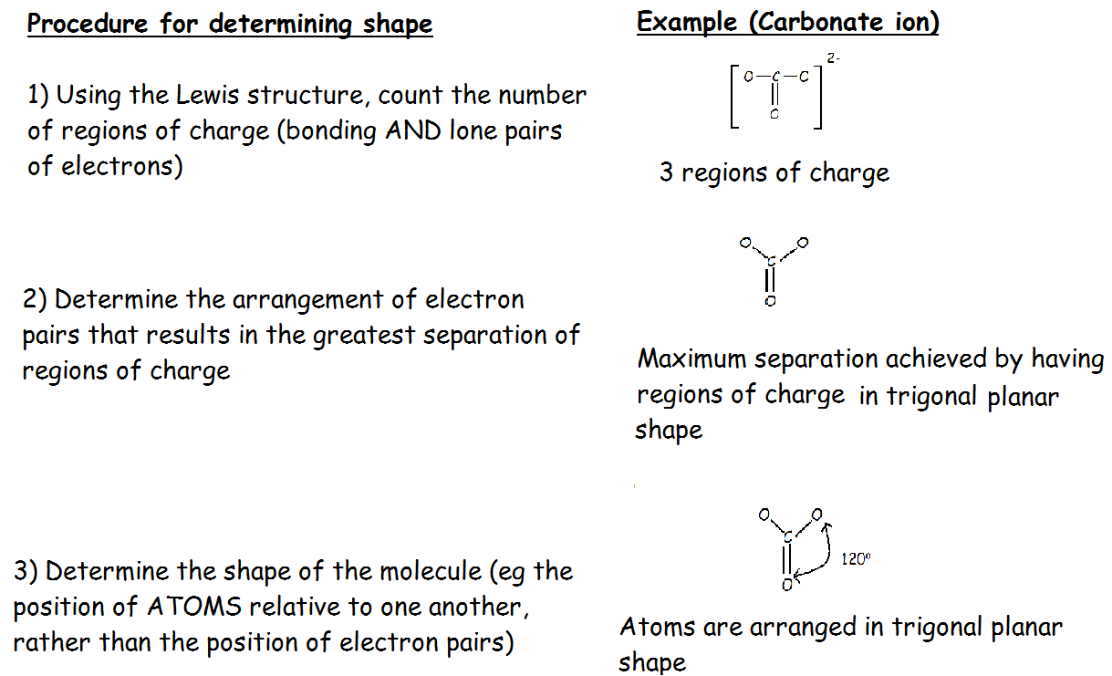

1. Determine the bond angle. These can vary slightly from maximum separation, as bonding pairs and lone pairs do not repel to exactly the same degree (see over page)

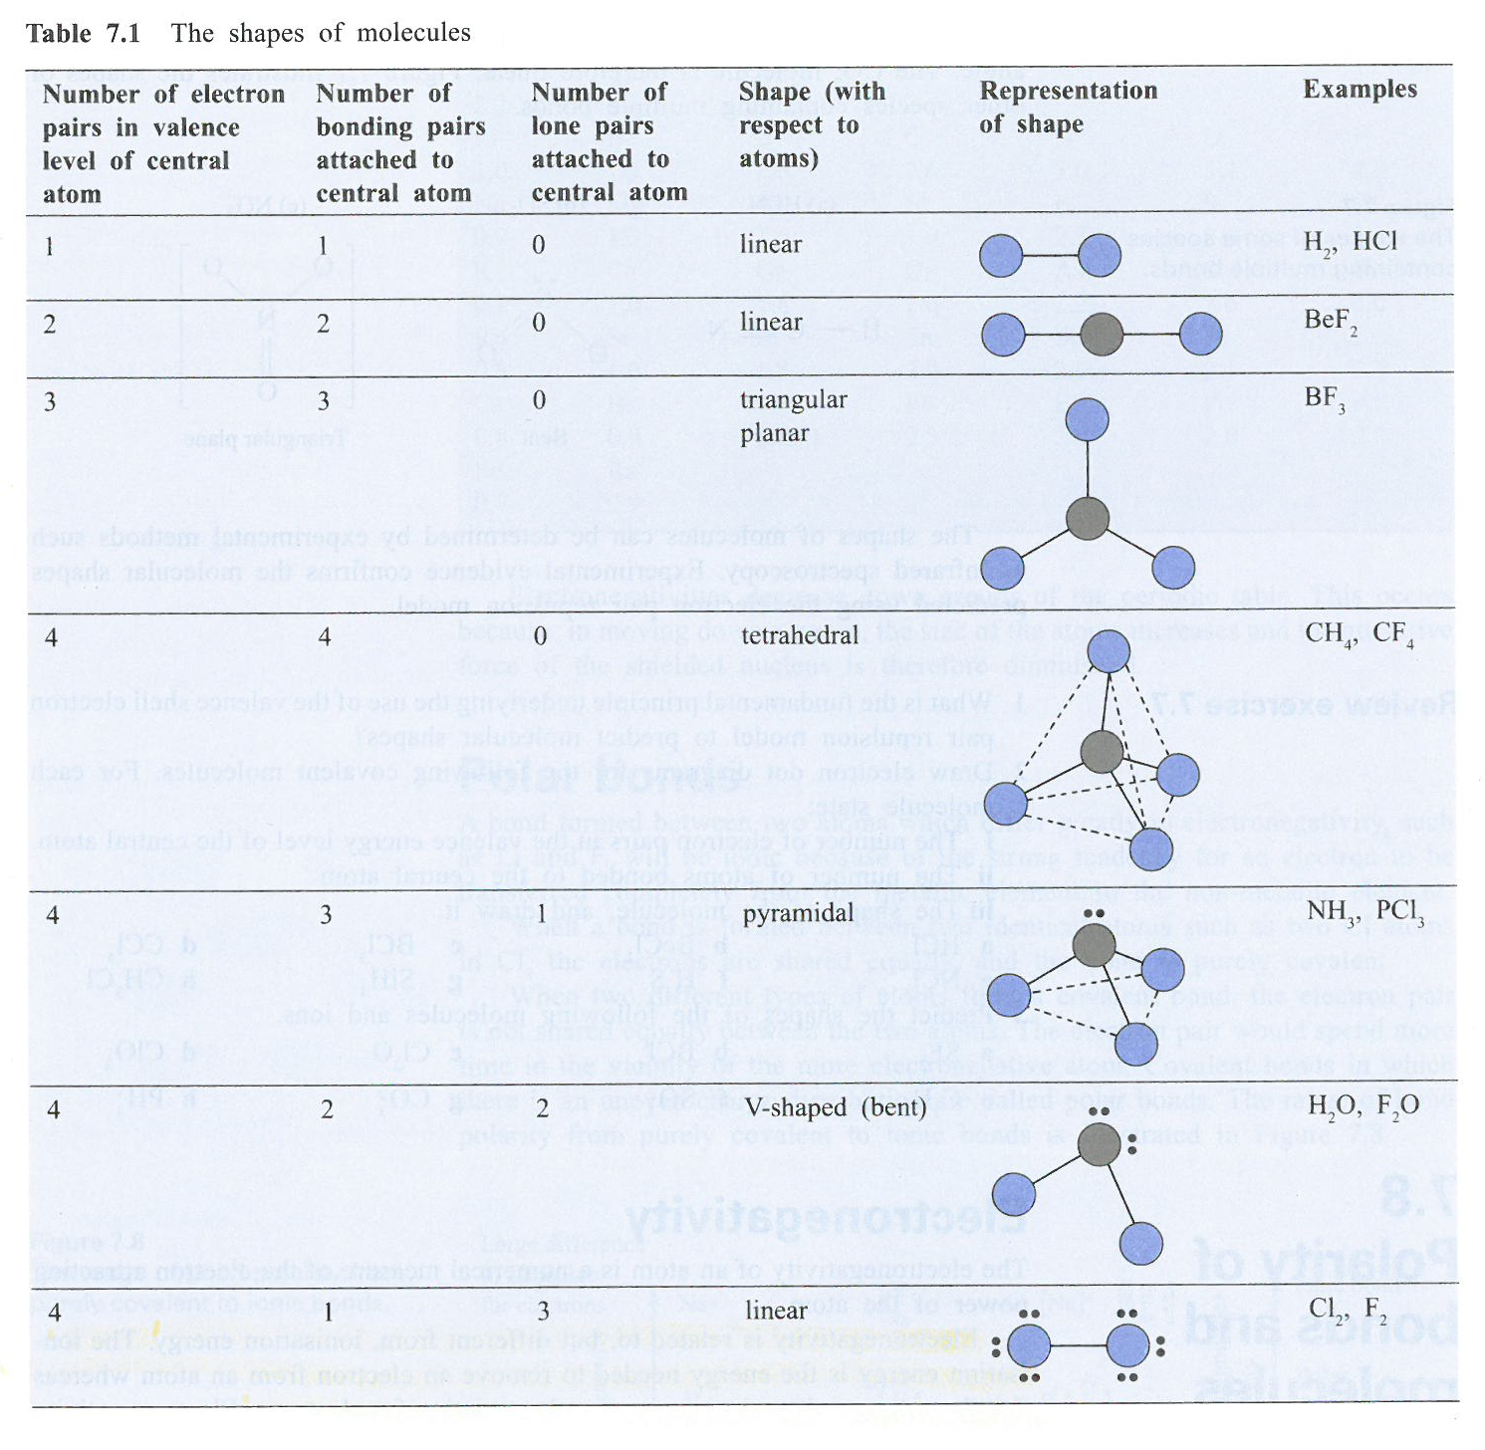

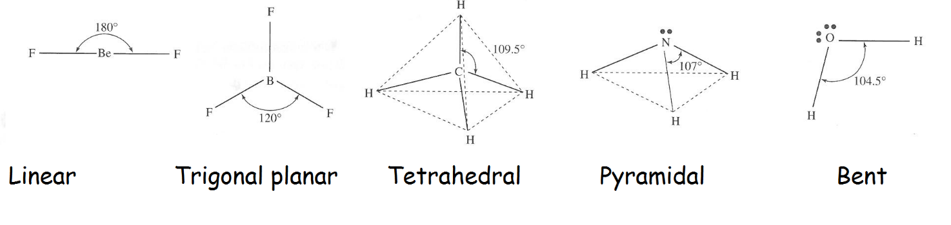Bond angles for different molecular shapes:

(bent can also be 120⁰ when there is a double bond present)

**Bond & Molecule Polarity**

-A molecular substances physical properties (MP, BP, solubility, etc) are determined by the nature and strength of its intermolecular forces

-The relative strength of these forces is determined by the polarity of the molecule (whether there is an uneven charge distribution)

-The polarity of a molecule is a consequence of the polarity of its intramolecular bonds (whether bonding electrons are shared evenly) and the 3-dimensional shape of the molecule

**Bond Polarity**

-Electronegativity is the measure of an atoms ability to attract bonding electrons

-In a covalent bond between atoms with unequal electronegativity (essentially any 2 atoms of different elements), the bonding electrons will be unequally shared

-The bonding electrons will spend more time in proximity to the atom with the greater electronegativity

-The atom with the greater electronegativity will develop a slight negative charge (б-) and the atom with the lower electronegativity will develop a slight positive charge (б+)

-Bonds with unevenly shared electrons are called polar bonds.



Example: Chlorine is far more electronegative than hydrogen. As such the bonding electrons in the H-Cl bond are unequally shared and the bond is polar

**Polar molecules**

-Molecules with an uneven charge distribution are called polar molecules

-These molecules contain **dipoles**, regions with equal but opposite positive and negative charges that are separated by some distance

-In the previous example, the HCl molecule is a polar molecule, because of the existence of the dipole that results from the polar H-Cl bond

-Not all molecules with polar bonds are polar, as it is possible for the dipoles to cancel each other out in a symmetrical molecule

-This is because the overall polarity of a molecule is found by vectorially adding the individual bond dipoles

-In order to be polar a molecule must (1) have one or more polar bonds and (2) not be completely symmetrical

**Types of Intermolecular Forces**

-There are three types of intermolecular forces, that differ based on the strength and permanence of the dipoles present

-A substance may have more than one type of Van der Waals force (eg all substances have dispersion forces, but some also have dipole-dipole forces or hydrogen bonding forces)

|  |  |  |  |
| --- | --- | --- | --- |
|  | **Dispersion** | **Dipole-Dipole** | **Hydrogen Bonding Forces** |
| Electrostatic attraction between: | -Temporary dipoles on adjacent molecules that arise due to temporarily uneven electron distribution | -Dipoles on adjacent polar molecules | -Strong dipoles on adjacent molecules, arising due to highly polar H-N, H-O or H-F bonds. |
| Relative strength | -Weakest | -Stronger | -Strongest (but still much weaker than true bonds) |
| Increase with: | -Number of electrons in molecule  -Surface area over which attractions can occur | -Increasing polarity of molecules  -Increasing charge density | -Increasing polarity of molecules  -Increasing charge density |
| Diagram |  |  |  |

**Van der Waals forces and physical properties**

**Melting and boiling points**

-Melting and boiling points increase with increasing strength of intermolecular forces

-As such, MP and BP increase with increasing polarity, increasing molecular size and increased surface area (e.g. a linear molecule will have higher MP and BP than a branched molecule with the same chemical formula)

**Vapour Pressure**



-Vapour pressure is a measure of a substances tendency to evaporate

-Vapour pressure decreases with increasing IM forces, as molecules need to overcome greater forces to escape the surface of a liquid

-Substances with dispersion forces are more volatile (evaporate more readily) than substances with dipole-dipole forces or hydrogen bonding forces

**Solubility**

-Solutes will tend to dissolve in solvents with similar intermolecular forces, as the solute particles are better able to interact with the solvent

-Water a polar solvent will tend to dissolve polar substances like ethanol (hydrogen bonding forces) and many but not all ionic substances (ionic bonds can be thought of as “extra-polar” bonds)

-Polar solvents like water will not dissolve non-polar substances like oils, grease etc

-Non-polar solvents like kerosene will dissolve non-polar substances (oils etc), but not polar substances

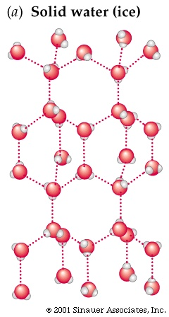

**Special properties of water resulting from its intermolecular forces**

-Water is a highly polar molecule that displays strong hydrogen bonding forces

-This results in an unusual 3D crystal structure in the solid state due to hydrogen bonds between oxygen atoms and hydrogen atoms on adjacent water molecules

-This decreases the density to the point where water is one of the only substances with a lower density as a solid than as a liquid

-Water's strong hydrogen bonding forces also result in its extremely high surface tension, causing it to form spherical droplets and allowing insects to walk on its surface

**IMF Summary**

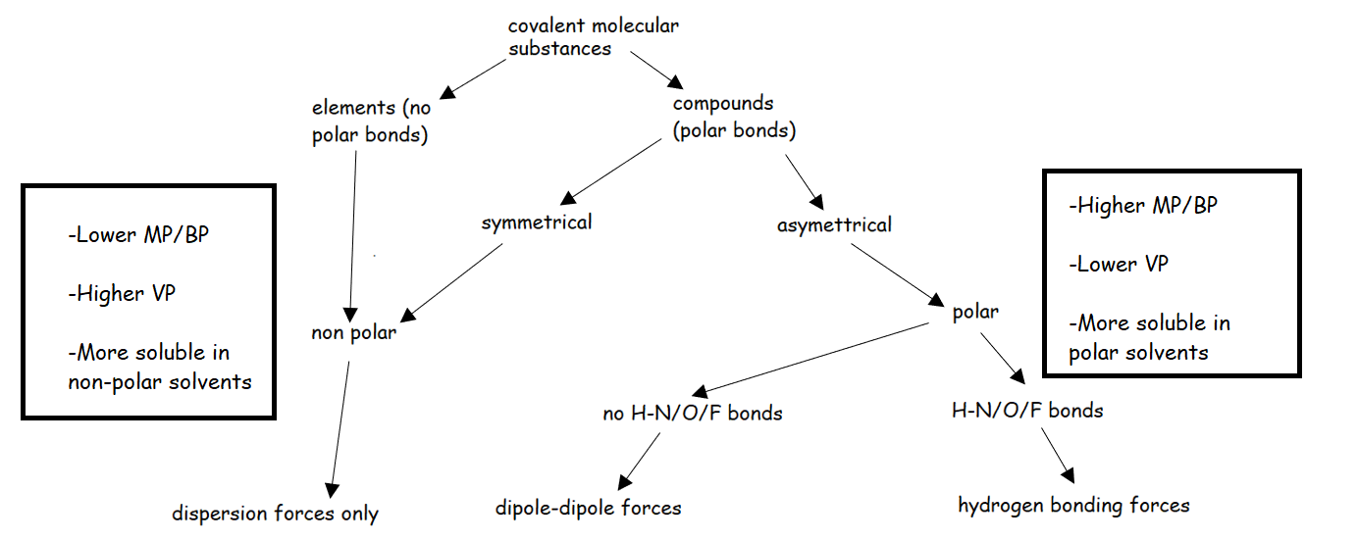

**Chromatography**

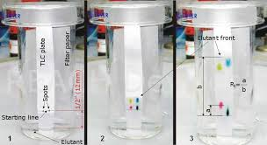

-Chromatography is a method for separating and identifying the components of a mixture (analytes)

-Analytes are separated on the basis of their intermolecular forces

**How it works**

-All types of chromatography consist of a stationary (solid) phase with a mobile phase (liquid solvent or a gas) moving over it

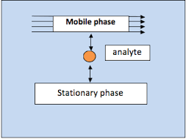

-When the mixture is added, components of the mixture will dissolve in the mobile phase or adsorb (stick) to the stationary phase to different extents

-Substances that dissolve in the mobile phase will be carried with it, moving them through the chromatography medium

-The components of the mixture become separated as substances that spend more time dissolved in the mobile phase move further along the chromatography medium, becoming separated from the components that spend more time adsorbed to the stationary phase

-The separation is determined by the intermolecular forces of the substances, as this determines which phase they will best interact with

-Chromatography commonly uses a polar stationary phase and a non-polar mobile phase, leading to separation of analytes based on polarity, with non-polar substances travelling the furthest

**Types of chromatography (types marked with * are non-assessable)**

**Paper Chromatography**\*



-Stationary phase: Strip of chromatography paper (polar)

-Mobile phase: Solvent (non-polar)

-How it works: The mixture is spotted onto the paper. The solvent travels up the paper by capillary action, carrying the components of the mixture with them.

**Column Chromatography\***

-Stationary phase: Small beads of alumina or silica in a glass column (polar)



-Mobile phase: Solvent (non-polar)

-How it works: The mixture is placed at the top of the column. The solvent flows downwards through the column bringing the components of the mixture with it. Non-polar substances travel further.

**Thin Layer Chromatography (TLC)**

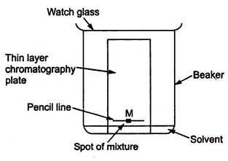

-Stationary phase: Glass plate coated in alumina or silica (polar)

-Mobile phase: Solvent (non-polar)

-How it works: The mixture is spotted onto the plate. The solvent travels up the plate by capillary action, carrying the components of the mixture with them. Non-polar substances travel further.

**Gas Chromatography (GC)**



-Stationary phase: High boiling point non-volatile liquid adsorbed onto solid particles within a stainless steel column

-Mobile phase: Chemically inert carrier gas

-How it works: The mixture is added to the carrier gas stream and vapourised. More volatile analytes have a greater tendency to remain in the mobile phase and move through the column quicker (have lower retention time).

**High Performance Liquid Chromatography (HPLC)**

-Stationary phase: Tightly packed fine solid particles (e.g. silica) within a column

-Mobile phase: Liquid solvent (in normal phase HPLC the mobile phase is non-polar, but in reverse phase HPLC a polar mobile phase and non-polar stationary phase are used)

-How it works: The mixture is injected into a sample injection loop and carried through the column by the solvent. Analytes with a similar polarity to the solvent have a lower retention time.

**Analysis of Chromatography Data**

-When conducting chromatography, the analysis focusses on the movement of analytes though the system

-This can be measured in absolute terms, or relative to the movement of the mobile phase

**Retention Time** (CC, GC, HPLC)

-In Column, Gas and High Performance Liquid Chromatography analytes are detected as they exit the chromatography system.

-The time it takes for an analyte to move through the system is known as the retention time

-The higher the retention time, the stronger the interactions between an analyte and the stationary phase

-The retention time of an analyte in a given chromatography system should be constant

**Retardation Factor** (PC, TLC)

-In Paper and Thin Layer Chromatography, all analytes are placed in the system for the same amount of time

-Different analytes move different distances depending on how well they interact with the mobile and stationary phases

-Retardation factor (Rf) is a measure of the distance travelled by an analyte relative to the distance travelled by the mobile phase (eg the solvent front)

-Rf = (distance travelled by analyte) / (distance travelled by solvent front)

-The Rf of an analyte in a given chromatography system should be constant.

**Advantages/Disadvantages of Different Types of Chromatography**

|  |  |  |  |
| --- | --- | --- | --- |
|  | **TLC** | **GC** | **HPLC** |
| Qualitative or Qualitative | Qualitative | Qualitative & Quantitative | Qualitative & Quantitative |
| Detection type | -Can be non-specific (e.g. iodine vapour) or specific (e.g. antibody related methods) | -Flame ionisation detector (gives retention time) or mass spectrometer (can identify analyte) | -UV detector (UV absorbance can be used to calculate concentration) |
| Uses | -Simple/cheap screening tests for drugs (require GC confirmation), separating dyes etc. | -Environmental monitoring, forensic testing, drug testing etc. | -Analysis of mixtures containing larger molecules (fats, oils, amino acids etc) in research or food & beverage industry |
| Limitations | -Not quantitative, prone to false positives | -Run at temperatures up to 250 °C, which causes some substances (M > 300 gmol-1) to decompose | -$$$  -Volatile substances are better separated by GC |